Notes:
10/11/2021
2.6 lbs
1 shallot
Forgot garlic, used garlic powder
Mistakenly cooked at 450 for 20min of the first hour, and meat was dry (though temp did not overcook, got up to 145)
Didn’t have as much nice umami
Didn’t make sauce
Should have let it rest longer

12/25/2019
4.5 lbs
1.5 cups shallots (5), but browned them in cast-iron pan along with garlic before putting in pork. Turned out really nice. Only thing left to do was to slather mustard on.
took ~ 1.25 hours to cook
no sauce
was a little overcooked, took out of oven at 140, temp never got above that
let rest for a long long while

11/20/2018
3.6 lbs
used 1 cup shallots
1 tbsp garlic
4 tbsp mustard
Took out at 133, let sit for 45 min, worked out ok.

Still didn't make the sauce.

7/2018
a lot of browning in cast iron
shallots were coarser, only needed about 2 shallots, not 4-5 to get a 1/2 cup
made in pyrex
still didn't make the sauce
3.5 lbs roast (about 20$?) cooked in the oven for about 1 hour until it got up to temp.
140 internal was too well done
makes *a lot* of food. Twice what we needed for 5 adults.

rested for 30-45 minutes after cooking, covered by tinfoil, is very resilient to sitting around like that and tastes good.

Making 12/2017--
a lot of browning
fat on top
shallots were coarser (easier)
made in pyrex
still didn't make the sauce 😃
never actually got up to internal 140 -- not sure why? Had fat layer on top. Let it cook for 1.5 hours. Higher temperature needed?
takes a lot longer than expected.

4.5 lbs is a lot- easily enough for 10-12 reasonable eaters.

Shinji/Andy loved it

Fantastic -- made for Ayumi's bday in 2013
We never make the sauce.

http://www.gourmet.com/recipes/2000s/2009/04/herb-roasted-pork-loin

HERB-ROASTED PORK LOIN
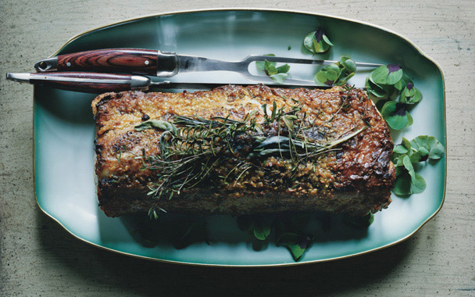SERVES8
- ACTIVE TIME:20 MIN START TO FINISH:1 1/2 HR
APRIL 2009
This handsome roast elicited oohs and aahs in the test kitchen when Ruggiero pulled it out of the oven, and the succulent meat disappeared in a flurry of forks. The rosemary, thyme, sage, and savory sprigs on which the pork loin roasts infuse the meat and mingle with its mustard and shallot cloak. The luscious sauce is argument enough for keeping a bottle of dry vermouth on hand.

View more of our favorite recipes from this issue.

FOR PORK
- 1 (4- to 4 1/2 lb) boneless pork loin roast, trimmed
- 2 tablespoons plus 1 teaspoon olive oil, divided
- 6 rosemary sprigs, divided
- 8 large thyme sprigs, divided
- 8 sage sprigs, divided
- 8 savory sprigs (optional), divided
- 1/2 cup finely chopped shallots (4 to 5)
- 2 tablespoons finely chopped garlic
- 3 tablespoons Dijon mustard

FOR SAUCE
- 1/3 cup dry vermouth
- 2 teaspoons Dijon mustard
- 1 3/4 cups reduced-sodium chicken broth
- 1 1/2 tablespoons unsalted butter
- 1 1/2 tablespoons all-purpose flour

ROAST PORK:
- Preheat oven to 350°F with rack in middle.
- Pat pork dry and season with 1 3/4 tsp salt and 1 1/2 tsp pepper. Straddle a flameproof roasting pan over 2 burners, then heat 1 Tbsp oil over medium-high heat until it shimmers. Brown pork on all sides, then transfer to a large plate.
- Put a metal rack in pan and arrange half of herbs down middle of rack. Stir together shallots, garlic, mustard, and 1 Tbsp oil and smear over top and sides of roast, then put roast, fat side up, on top of herbs. Roast 1 hour. Toss remaining herbs with remaining tsp oil and arrange on top of roast.
- Continue roasting until an instant-read thermometer registers 140 to 145°F, 5 to 15 minutes more (temperature will rise 5 to 10 degrees as it rests). Transfer pork to a cutting board and let rest 15 to 25 minutes.

MAKE SAUCE WHILE PORK RESTS:
- Remove rack from pan and discard herbs from rack. Straddle pan across 2 burners on medium heat. Add vermouth and mustard and deglaze by boiling, stirring and scraping up brown bits, until reduced by half. Add broth and simmer 3 minutes. Strain through a fine-mesh sieve into a 2-cup measure. If you have more than 1 1/2 cups, boil to reduce; if less, add water.
- Melt butter in a heavy medium saucepan over medium heat. Whisk in flour and cook, whisking, until pale golden, about 3 minutes. Whisk in vermouth mixture and simmer until slightly thickened, about 3 minutes.
- Serve pork with sauce.

